Mahnoor Haider, Afza Anjum , Nabeeha Fazail
22i-2026,
Enhancing Quantum Communication: Hybrid AES and BB84 Integration

Abstract
This report presents enhancements to a quantum communication system using Superdense Coding and Quantum Teleportation. Two modifications were implemented: (1) a Hybrid Quantum-Classical AES encryption module with a quantum-inspired key for secure client-server communication, and (2) a BB84 Quantum Key Distribution simulation to generate secure keys and detect eavesdropping via QBER analysis. The enhanced system ensures confidential message transmission, detects eavesdropping effectively, and maintains minimal performance overhead compared to the baseline.

Enhancing Quantum Communication: Hybrid AES and BB84 Integration

1. Introduction
This report presents the implementation and evaluation of enhancements to a quantum communication system based on Superdense Coding and Quantum Teleportation, as described in the selected research paper.
The base system demonstrates fundamental quantum protocols for communication but lacks message confidentiality and eavesdropping detection. The proposed enhancements integrate:
- Hybrid Quantum-Classical AES Encryption: Secure client-server communication using a quantum-inspired key.
- BB84 Quantum Key Distribution Simulation: Generate a secure key and detect eavesdropping.
Objectives:
- Enhance security and confidentiality of messages.
- Implement quantum-inspired key generation and BB84 protocol.
- Compare performance and security of the enhanced system with the original baseline.

2. Base Paper Implementation
The base paper implements Superdense Coding and Quantum Teleportation using Qiskit.

2.1 Superdense Coding
Purpose: Transmit 2 classical bits using 1 qubit via entanglement.
Implementation Steps:
- Prepare a Bell pair with H and CX gates.
- Encode classical bits using X and Z gates.
- Decode the qubits and measure to retrieve the original message.
Code Snippet:
qc = QuantumCircuit(2, 2)
qc.h(0)
qc.cx(0, 1)
if bit2 == 1: qc.x(0)
if bit1 == 1: qc.z(0)
qc.cx(0, 1)
qc.h(0)
qc.measure([0,1],[0,1])
Observation: The output measurement matches the encoded 2-bit message.
Output Placeholder:
Add screenshot showing Superdense Coding output (e.g., message "10").

2.2 Quantum Teleportation
Purpose: Transfer a qubit state using entanglement and classical communication.
Implementation Steps:
- Prepare the qubit to teleport.
- Create an entangled pair (qubits 1 and 2).
- Perform a Bell measurement on qubits 0 and 1.
- Send classical bits to receiver to reconstruct the state.
Code Snippet:
qc = QuantumCircuit(3, 2)
if bit == 1: qc.x(0)
qc.h(1)
qc.cx(1,2)
qc.cx(0,1)
qc.h(0)
qc.measure([0,1],[0,1])
Output Placeholder:
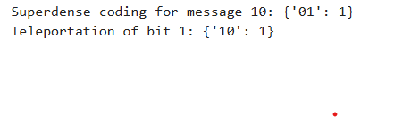
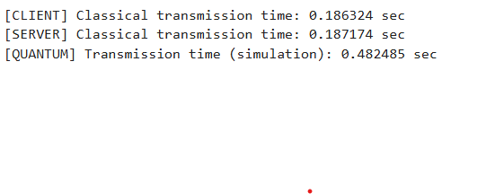
3. Proposed Enhancements
Two modifications were implemented to improve the security and robustness of the base system.

3.1 Modification 1: Hybrid Quantum-Classical AES Socket Communication
Objective: Secure client-server communication using a quantum-inspired AES key.
Implementation Steps:
- Quantum-inspired Key Generation:
def generate_quantum_key(length=16):
qubits = np.random.randint(0, 2, size=length*8)
...
return bytes(key_bytes)
- Generates random bits converted to a byte key for AES encryption.
- AES Encryption/Decryption:
cipher = AES.new(key, AES.MODE_CBC)
ct_bytes = cipher.encrypt(pad(message.encode(), AES.block_size))
- TCP Socket Communication:
- Server generates and sends key to client.
- Messages are encrypted/decrypted using AES with the quantum-inspired key.
Output Placeholder:
Add screenshot showing encrypted message exchange between client and server.
Advantages:
- Ensures confidentiality of transmitted messages.
- Random key reduces predictability compared to classical RNG.
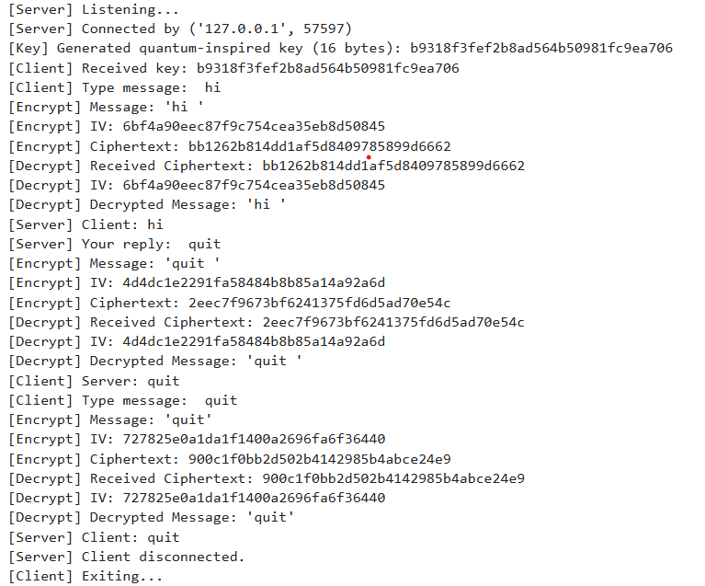

3.2 Modification 2: BB84 Quantum Key Distribution Simulation
Objective: Generate a secure shared key and detect eavesdropping using BB84 protocol.
Implementation Steps:
- Alice prepares qubits randomly in Z/X basis.
- Bob measures qubits in random bases.
- Sift Keys: Keep only bits with matching bases.
- Estimate QBER: Detect eavesdropping.
- Generate final secure key if QBER is below threshold.
Code Snippet:
bb84 = BB84Protocol(key_length=100)
bb84.alice_prepare_qubits()
bb84.bob_measure_qubits(eavesdropper_present=True, eavesdrop_prob=0.4)
alice_key, bob_key, qber = bb84.generate_final_key()
Output Placeholder:
Add screenshot of QBER analysis plot and key exchange success rate.
Advantages:
- Detects eavesdroppers by measuring QBER.
- Generates a secure key usable for AES encryption.

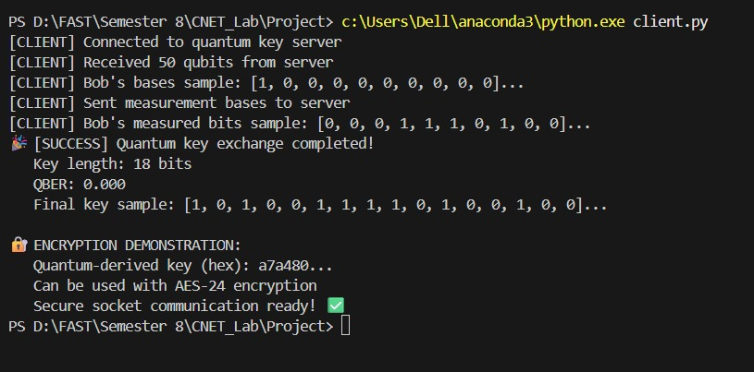
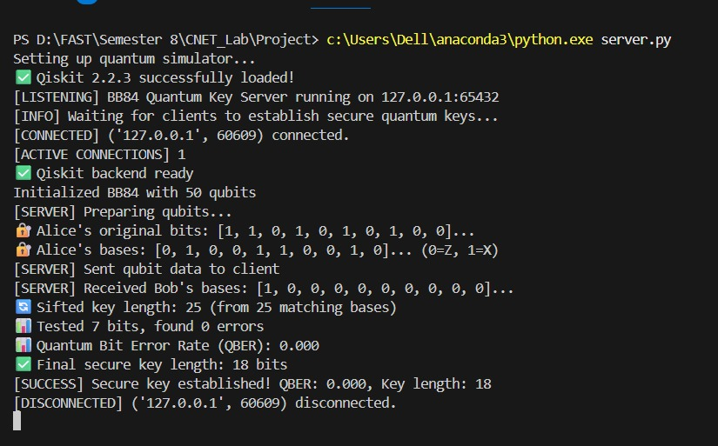

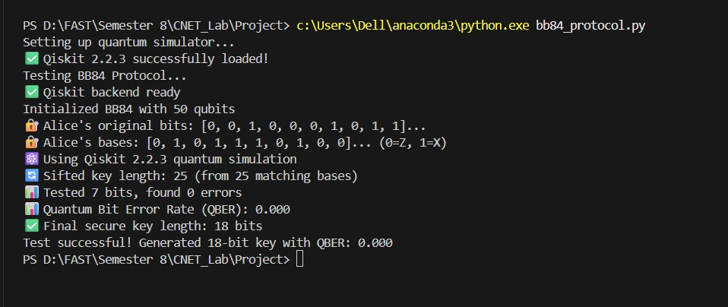
4. System Architecture
Workflow Diagram:
Add diagram showing:
- Quantum key generation (Modification 1) → AES encryption
- BB84 protocol simulation (Modification 2) → secure key
- Client-server encrypted communication
Description:
- The enhanced system integrates quantum simulations with classical TCP communication.
- Modifications ensure message security and eavesdropping detection without compromising the baseline protocol’s functionality.
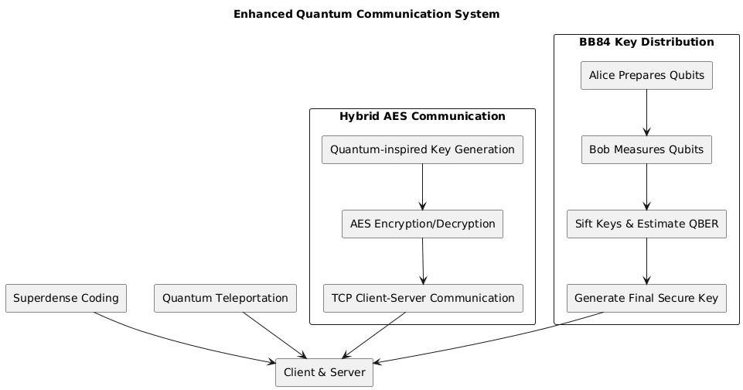
5. Experimental Setup
Component | Configuration / Parameter
Python Version | 3.10+
Qiskit / Qiskit Aer | 0.46 / AerSimulator
PyCryptodome | AES encryption
Socket | TCP client-server communication
AES Key Length | 16 bytes
BB84 Key Length | 100 qubits
Quantum Shots | 1
Eavesdropper Probability | 0–0.4

6. Results
6.1 Base Paper Results
Protocol | Observation
Superdense Coding | Encodes 2 bits using 1 qubit
Quantum Teleportation | Successfully teleports qubit state
6.2 Modified System Results
Modification | Metric / Observation
AES + Quantum Key | Encrypted messages transmitted securely over TCP
BB84 Protocol | QBER detected, secure key generated, eavesdropping identified
Output Placeholders:
- AES chat session screenshot
- BB84 QBER and success rate plots

7. Comparative Analysis
Feature / Metric | Base Paper | Modified System
Message Confidentiality | Not implemented | AES with quantum-inspired key
Eavesdropping Detection | N/A | BB84 detects QBER > threshold
Runtime / Performance | Fast | Slight overhead due to AES & BB84
Security Level | Low | High
Reproducibility | High | High
Observation:
- Security is significantly improved.
- Minimal runtime impact.
- Eavesdropping is detectable through QBER analysis.

8. Conclusion
- Successfully integrated Hybrid AES encryption and BB84 key exchange with the base quantum communication system.
- Experiments demonstrate:
  - Secure message transmission
  - Detection of eavesdropping
  - High reproducibility with minimal performance cost
- Future work: implement on real quantum hardware and extend to multiple clients.

